Properties of a spring damper

Ks = Spring constant

Kd = Damping factor

Lo = Rest length

P1 = Particle one

P2 = Particle two

Computing the spring force

1. Convert all the 3D distances and velocities into 1D
2. Compute the spring force in 1D
3. Turn the 1D force into a 3D force

Computing the spring force

Calculate the unit length vector between the two particles

E\* = r2 – r1 // make sure we don’t override the local variables

Calculate the difference between the two particles

L = |e\*| // e is the unit length vector

L = magnitude of the difference between the two particles

E = e\* / l

E = unit length vector

Be sure to normalize e\*.

Computing the spring force

Calculate the 1D velocities

v1 = particle one velocity

v2 = particle two velocity

V1 = dot (e, v1)

V2 = dot (e, v2)

Convert from 1D to 3D

Fs-d = -Ks\*(Lo – l) – Kd\*(V1 – V2)

F1 = fs-d\*e

F2 = -f1

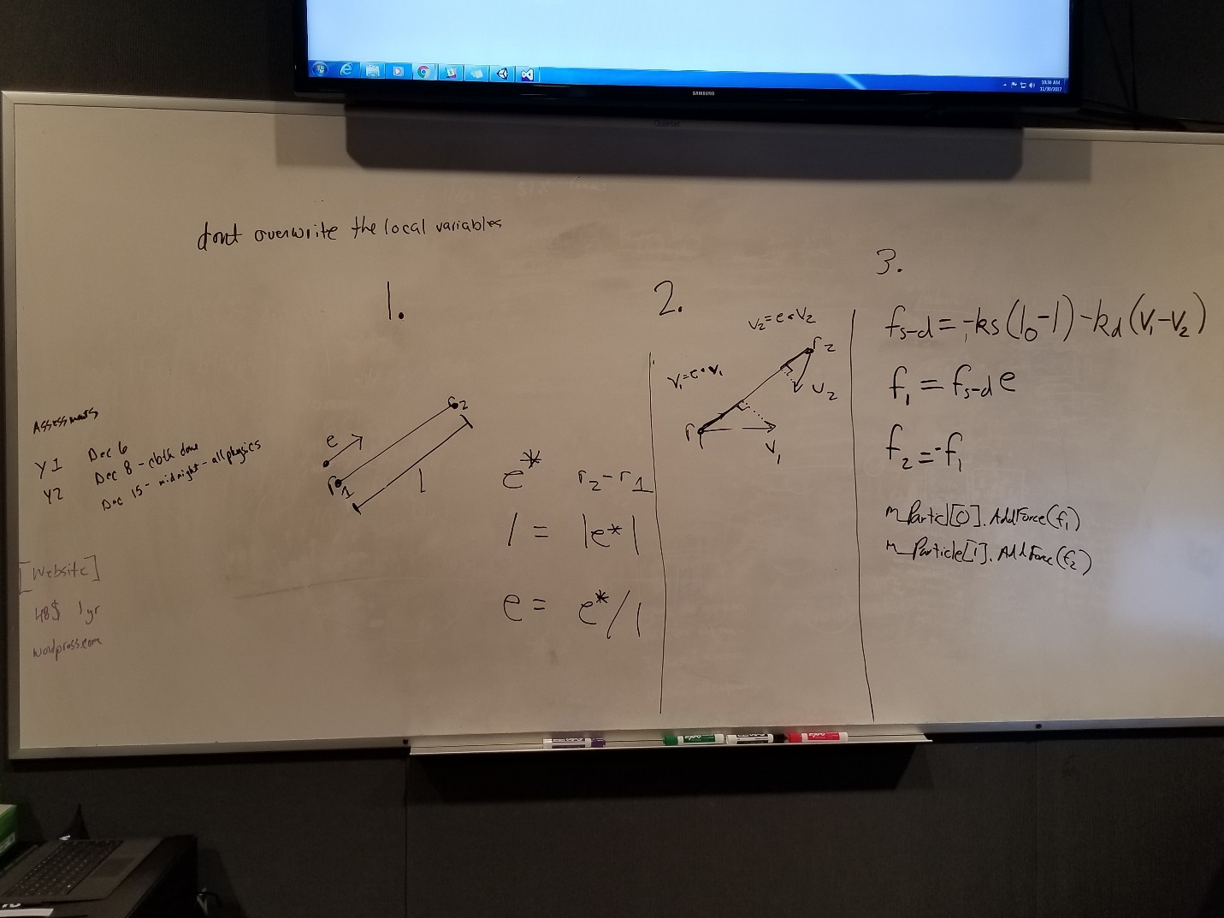

Steps

1. Compute forces

-for each particle: apply Gravity

-for each spring- damper: compute & apply forces

-for each triangle: compute and apply aerodynamic forces

1. Integrate motion

-for each particle: apply forward Euler integration

1. Repeat